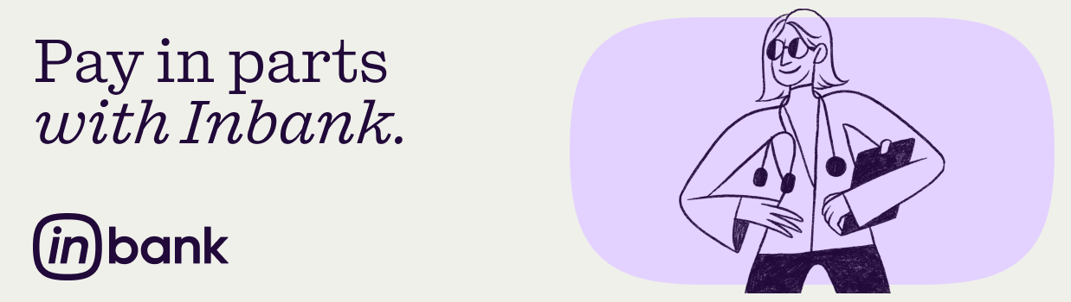

Don’t postpone your medical services – choose Inbank and pay in parts!

In collaboration with Inbank, we offer pay in parts plans for covering full or partial medical service costs.

Hire purchase terms:
- Amount from €75 to €10 000
- Period 3-72 months
- For purchases over €1400, a mandatory down payment of 10% is required

Who can apply for hire purchase:
- Customer over 19 years old
- Monthly income above €350
- Positive credit history

If you have any questions about hire purchase, contact Inbank Latvia at +371 66 939 000, info@inbank.lv, inbank.lv.

