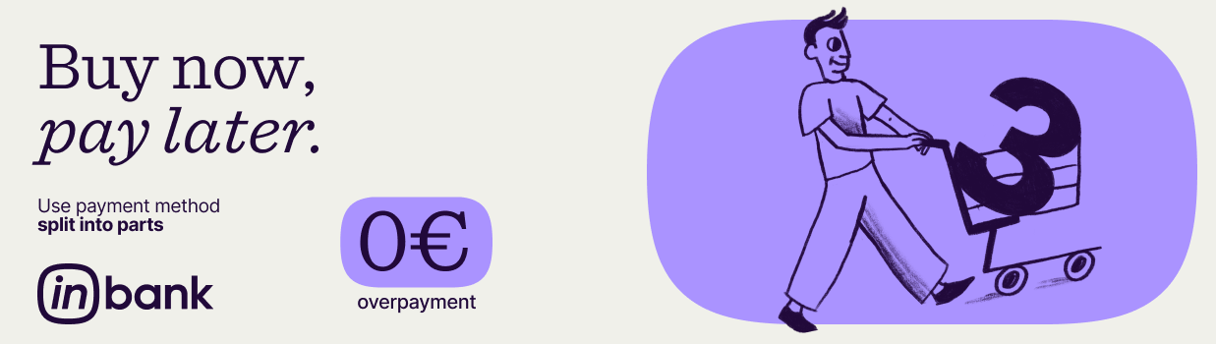

In collaboration with Inbank, we offer – payment method Split in parts!

Purchase everything you need right away and divide the total amount into 3 equal payments – with no interest, contract fees, or down payment.

Easy to apply
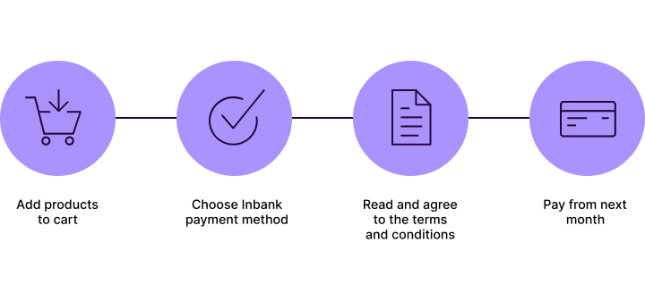
Terms:
- Amount from €75 to €2500
- Pay in 3 equal parts
- 0 € additional costs
- First payment in next month

Learn more about this payment method here.

If you have any questions about payment method, contact Inbank Latvia at +371 66 939 000, info@inbank.lv, inbank.lv.

